STAFF APPRECIATION AND RECOGNITION (STAR)

Berkeley STAR Nomination Form

Name of Nominee: |  |  |  |  |  |  |  |  |  | UCPath Employee ID:
Job Title: |  |  |  |  |  |  |  |  |  | Job Title Code:
Unit/Department Name: |  |  |  |  | Type of Award Spot Award
Provide a brief description (1-3 paragraphs) of the specific reason for nomination and linkage to one or more of the UC Achieve Together criteria. If the nomination is for an employee in another unit, please consult with the employee’s home unit regarding how the award cost will be covered.

Eligibility for award (both boxes must be checked):
The nominee is a non-represented employee or a represented employee in the Clerical (CX) represented bargaining unit.
The nominee has a rating of “meets expectations” or above and has no outstanding disciplinary actions.
Nominator Name: |  |  |  |  |  | Signature: |  |  |  |  | Date:
Nominator’s Unit: |  |  |  |  |  | Contact address:
E-mail address: |  |  |  |  |  | Phone:
Supervisor: (if other than Nominator) |  |  |  |  |  | Signature: |  |  |  |  | Date:
Next Level of Authority
Name: Signature: Date:
Office Use Only:
Award Approved  Award amount:  (copy to be placed in nominee’s Personnel File) |  |  |  |  |  |  | Guidelines:  - Up to $500 for Spot Award (less taxes)  - an employee can receive up to 4 spot awards
Award Denied
Reason for Denial:
Recognition Award Administrator Name: |  |  |  |  |  |  | Signature:
Job Title: |  |  |  |  |  |  | Date:

October 2021
Please complete this form and return to your Recognition Award Administrator.

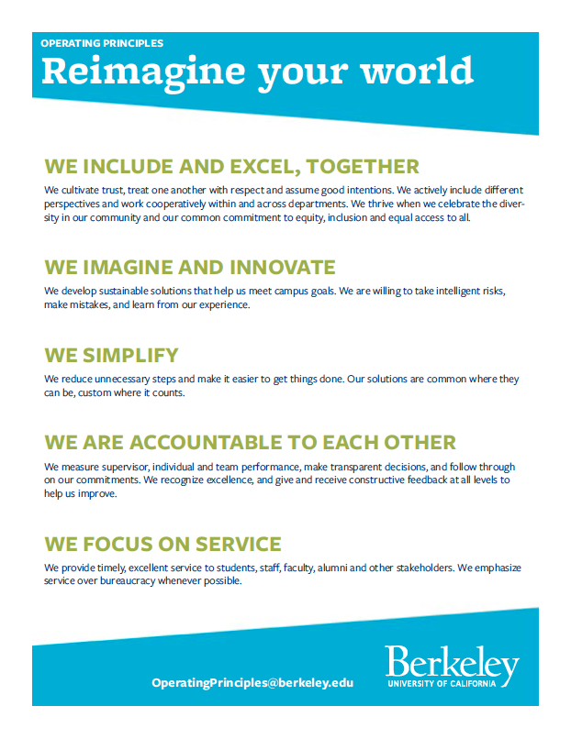
Berkeley Operating Principles

Examples of Spot Awards

Spot Awards
“In-the-moment contributions”
- We include and excel, together

Example: Instead of updating a lobby directory for just one department, an Administrative Assistant reaches out to all the building's occupants to gather their updates, resulting in a better, more inclusive sign.

- We imagine and innovate

Example: Student Services Advisor creates a comprehensive, informative matrix on the college website of financial aid sources for students, including eligibility criteria and other pertinent factors.

- We simplify

Example: A team of Financial Analysts works within a college over a short period of time to develop a standard budget process for a department within the college. Good leadership and teamwork results in a successful outcome.

- We are accountable to each other

Example: Human Resources Manager creates a culture for continuous feedback in the workplace by encouraging staff to mentor each other, recognize each other’s achievements, and offer constructive solutions when things aren’t going well.

- We focus on service

Example: Financial Analyst enrolls in a class to increase her financial modeling knowledge and, as a result, makes improvements in the financial modeling process in her department.

