Berkeley People Management

Development Plan Guide
Template

Planning for Continued Growth and Development

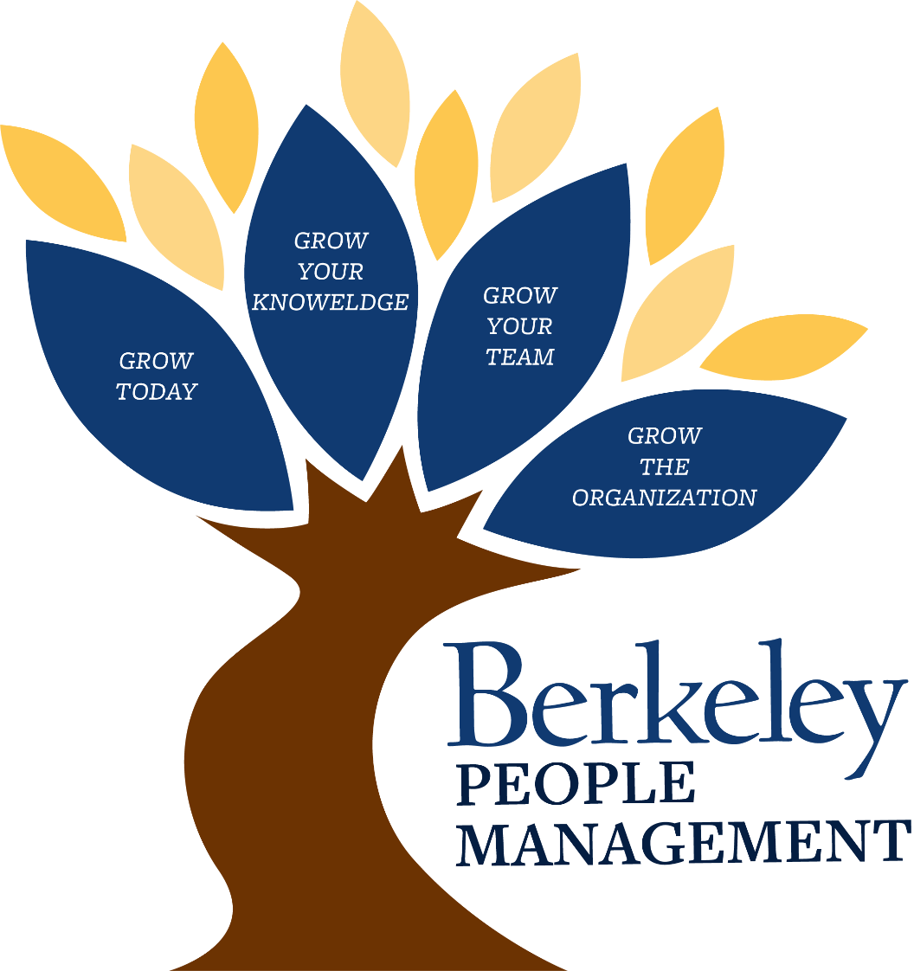

SECTION 1: USES OF THIS DEVELOPMENT PLANNING GUIDE

The Purpose of this Guide
The purpose of this guide is to assist you in planning for your personal leadership development. Keep the following guidelines in mind as you consider your strengths and developmental needs:
- As you get started, it’s important to seek out feedback so you can incorporate thinking from yourself and from those in your professional sphere. There are a number of ways to get actionable feedback. Some you might consider include informal conversations with your manager/peers/direct reports, more formal conversations such as an upcoming Achieve Together conversation, or even through a formal 360 undertaken by you and the People & Organization Development team.
- If this document or the process starts to overwhelm you, take some time to reflect before you continue. Take action when you are ready and know what you want to do.
- Remember, development is not about changing yourself so much that it feels inauthentic. Instead, it’s about building a plan that will help you to be the best that you can and want to be. You define what success is, and your development plan helps you to achieve that success.

Identify Your Development Priorities
We all have many opportunities to develop ourselves as leaders, managers, employees, and individuals. However, we cannot focus on everything at once. Try to link your development actions and priorities to your career objectives and desires.

As you consider your development priorities, use the below prompts to narrow your focus to 3 key development priorities.
- What behaviors are critical to the organizational culture in which you work?
- What is it critical for you to do to be successful in your current role?
- What behaviors will you need to demonstrate in the role to which you aspire?
- What behaviors must you demonstrate in order to be successful in the unique circumstances of your current situation?
- What behaviors must you demonstrate in order to be true to your personal values and beliefs?

If you need some helping thinking about what behaviors and competencies might be most impactful for you, considering looking at:
- The UC Systemwide Core Competency ABCs
- The Achieve Together Achievement Criteria
- The Berkeley People Management Leadership Competency Model

Complete Your Development Plan
Select up to 3 development priorities for which you will write a personal action plan and organize your thoughts in sections 2-5 of this document.

You will create your formal development plan in section 4. Keep the following in mind as you complete the chart:
- Describe, in behavioral terms, what you hope to achieve by developing in this area.
- List the actions you plan to take to achieve your development goal.
- Determine how you will measure your achievement on this action item.
- Commit to a completion date.
- Consider what support you require to achieve this development goal, and who you can count on to help you measure your growth.
- Identify the potential barriers to your success.
- Determine how you will deal with obstacles that may arise.
SECTION 2: IDENTIFY YOUR DEVELOPMENTAL PRIORTIES
Use this area to write down your own thoughts as you consider your developmental priorities. Be sure to list your current professional strengths, opportunities for growth and development, and if you think you have any knowledge/skill gaps that may impede your successful career growth.

Professional Strength | Opportunities for Growth | Gaps that Might Impede my Successful Career Growth
In my current role, the competencies / skills that I use successfully include: | In my current role, I would be more successful if I had stronger skills in the following areas: | As I think about my career growth over the longer term, these competencies / skills will be critical for me to develop.

Next, build an action plan including the people you will speak with and the question you will ask as you build a stronger understanding of your current professional behaviors, competency, and skills. Use these conversations to check, confirm and/or rethink your personal assessment above.

My Professional Network | Check: Behavior / Competency / Skill | Confirm / Rethink
List members of your professional network who you wish to speak with to check, confirm and/or rethink your self-assessment. | List the competency, skill, and/or behavior that this person has seen you perform. | List the questions you will ask as you speak with this person to gather their honest feedback about your skill level.

SECTION 3: REFLECTING ON YOUR DEVELOPMENT
Based on your career objectives and the feedback you’ve collected, use this section to identify your top 3 competencies for development and ensure they support your career objectives.

Describe what you aspire to achieve in your career 1, 2, and 5 years from now.

My Career Objectives
1 year from today, I want to: | I will know I’ve been successful in achieving this career goal when:
2 years from today, I want to: | I will know I’ve been successful in achieving this career goal when:
5 years from today, I want to: | I will know I’ve been successful in achieving this career goal when:
today, I want to: | I will know I’ve been successful in achieving this goal when:
Describe what you believe to be the key aspects of the role to which you most immediately aspire (this could be a job/position change or becoming stronger in your current role). If you are unable to answer this question, consider who you might speak with to further build your knowledge and understanding.

Critical Aspects of my Next Role
To be successful, I will need to be able to: | Consider the competency models listed on page 2 of this plan: Strengthening my skills in this competency will most positively impact my success.

You should now be able to list three competencies that will most effectively support your career development. As you identify your focus competencies, keep the following items in mind: organizational requirements, current and future role requirements, and personal motivators.
- ___________________________________
- ___________________________________
- ___________________________________
SECTION 4: YOUR DEVELOPMENT PLAN
Now that you’ve identified your focus competencies (the top three competencies which you believe will help you achieve your career aspirations), it’s time to build your plan.

Competency to Develop | Action Steps I will Take | Performance Metrics | People & Resources
My focus competencies | What action steps will I take to build skill in this competency? | How will I measure success for this action step? | What resources and support will I need?
 | 1
 | 2
 | 3
 | 4
 | 5
 | 1
 | 2
 | 3
 | 4
 | 5
 | 1
 | 2
 | 3
 | 4
 | 5

SECTION 5: INTERRUPTIONS / CONTINGENCY PLAN

What are potential interruptions to my development plan? How will I deal with them?
In this section, list any foreseeable interruptions to your plan in section 4 and how you may overcome them if they happen.

Potential Interruptions: | Contingency Plan:

