February 8, 2022

Job Builder (Action Requested) Missing Position Number Associated with Classified Job Description
Dear PD Owner,

You are receiving this email because you’ve been identified to have one or more Classified Job Descriptions in the current Job Builder system that are missing a Position Number/Position ID. With the upcoming transition to the new Job Builder powered by JDXpert, it is imperative that the Position Number is included on the job description form as this will ensure a smooth transition between the two systems. You can visit the P&C Job Builder website for more information about the new Job Builder platform. Resources, training videos, and implementation date will be forthcoming.

This google sheet lists PD Owner Names alongside their respective Position Descriptions that need to be reviewed. To review your position descriptions; log into Job Builder, go to My Position Descriptions tab, and under the Action column click on ‘Select’ to open and view each JD. Make sure the Position Descriptions have the appropriate Position Number updated and saved to the system. If a JD is missing the Position Number, click on Edit to input the Position Number (i.e. Position ID field) and save.
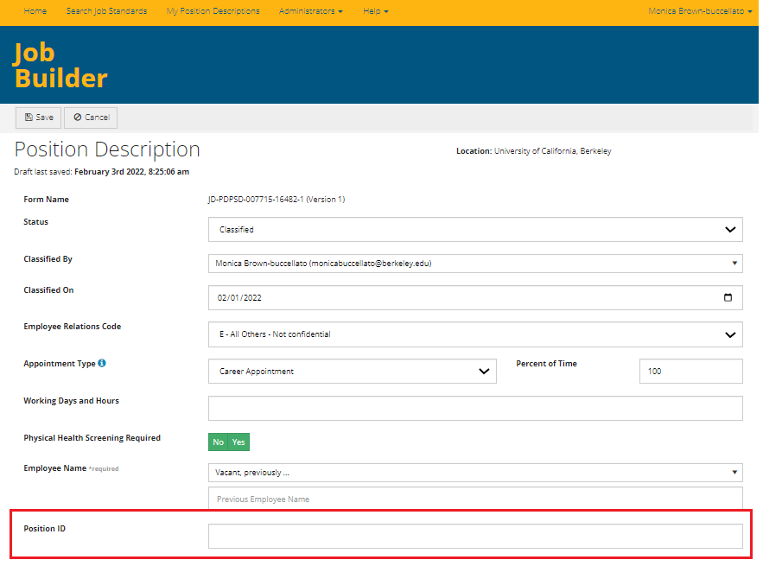

Don't know the Position Number? You can find the Position Number in UCPath. Continue to work with your dedicated HR Partner for assistance in verifying position numbers as necessary.

Questions? Email compdesk@berkeley.edu.
Ideally this will be complete before the end of February. We look forward to partnering with you. If you have any questions please don’t hesitate to reach out.
Best Regards,
Monica and Jennifer

Monica Brown-Buccellato, Compensation Consultant, Job Builder Project Lead
Jennifer Lei, Compensation Student Assistant, Job Builder Project Support

